# NAME :P.PREMKUMAR

# REG NO :192111446

# COURSE :COMPUTER ARCHITECTURE

# CODE :CSA1288

# FACULTY :DR.MARY VALANTINA.G

# DATE :08/10/22

Write a program to convert Decimal number to Hexadecimal number using any high level language.

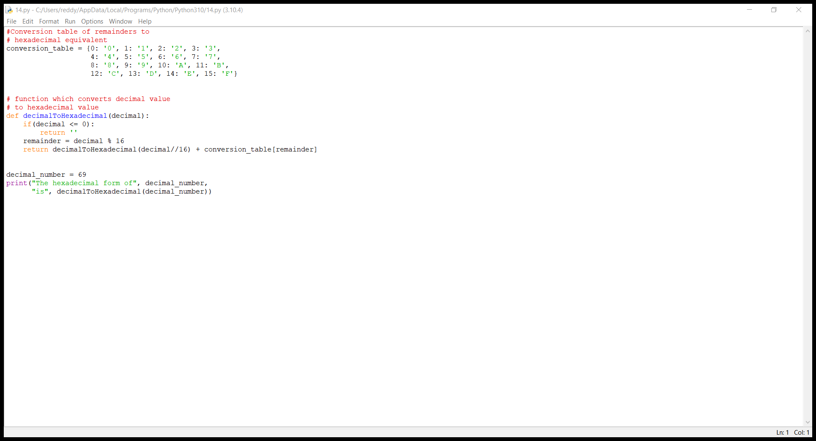

Write a program to convert Binary to Octal number using any high level language

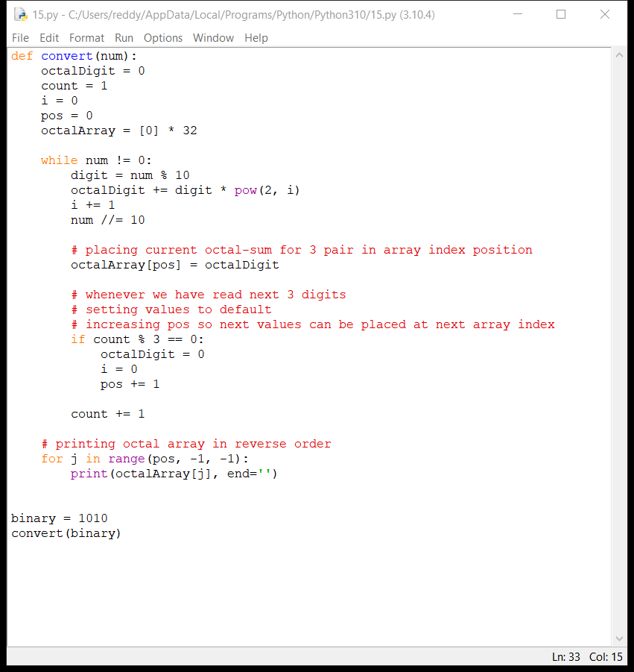

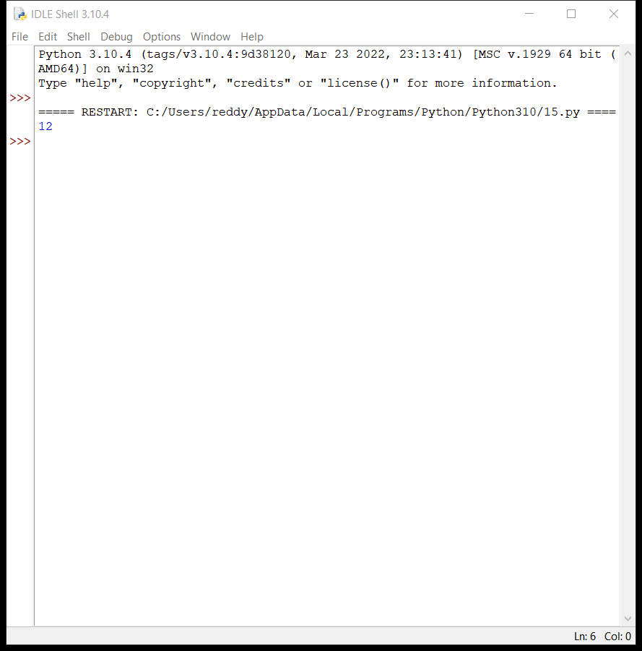

Write a program to convert Binary to Hexadecimal number to number using any high level language.

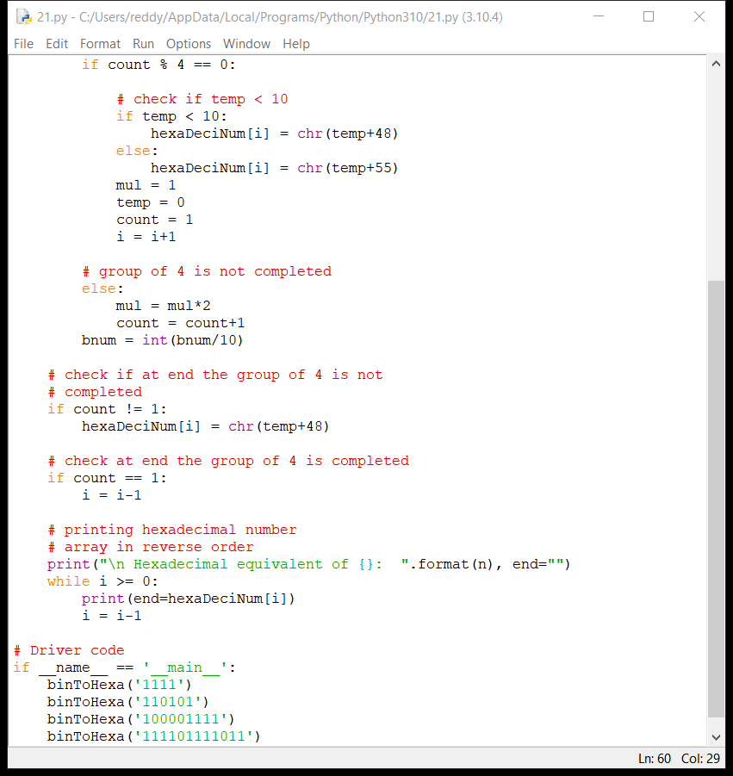

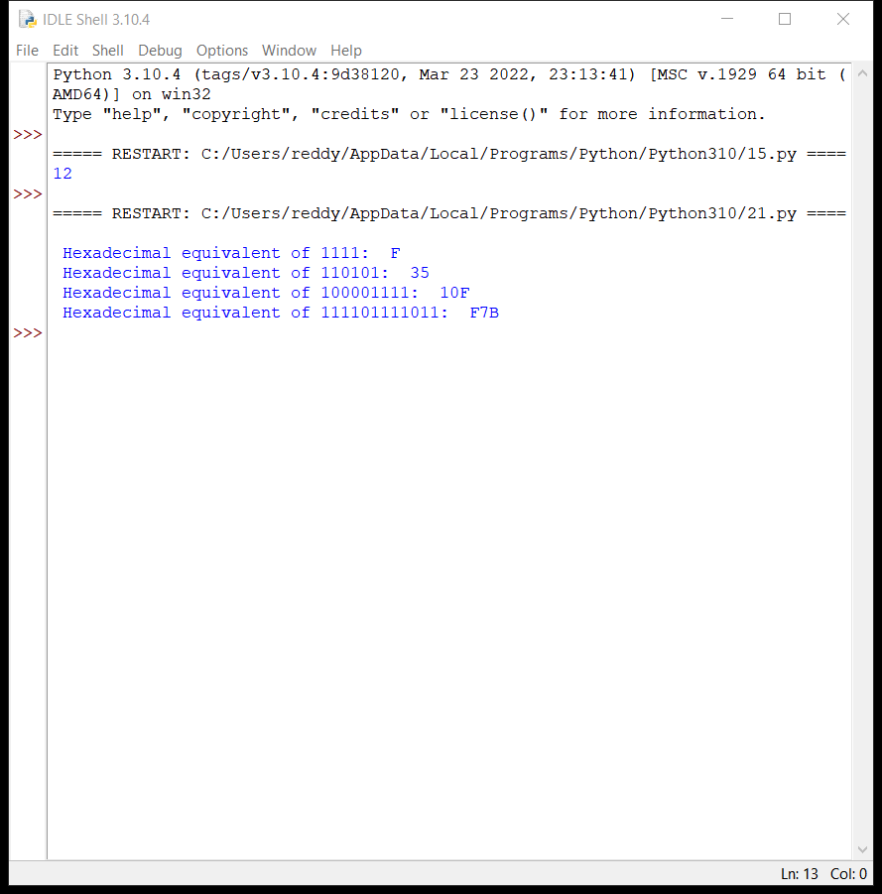

Write an assembly language program for adding two 16-bit datausing 8086 processor.

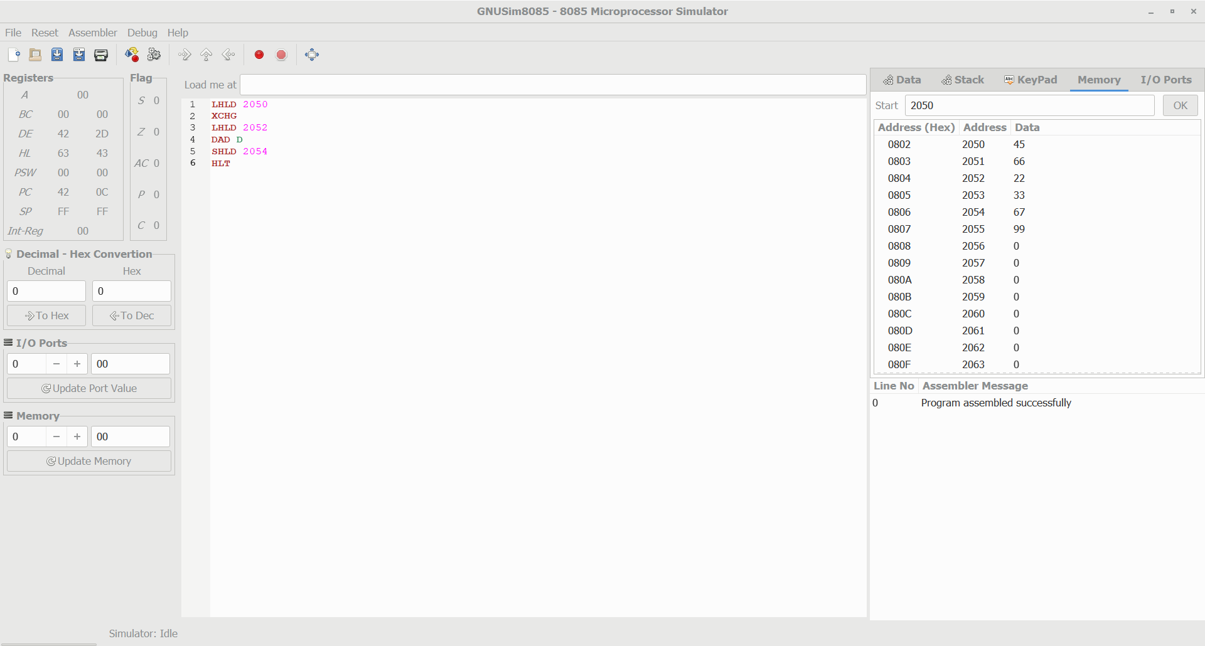

Write an assembly language program for subtracting two 16-bit datausing 8086 processor.

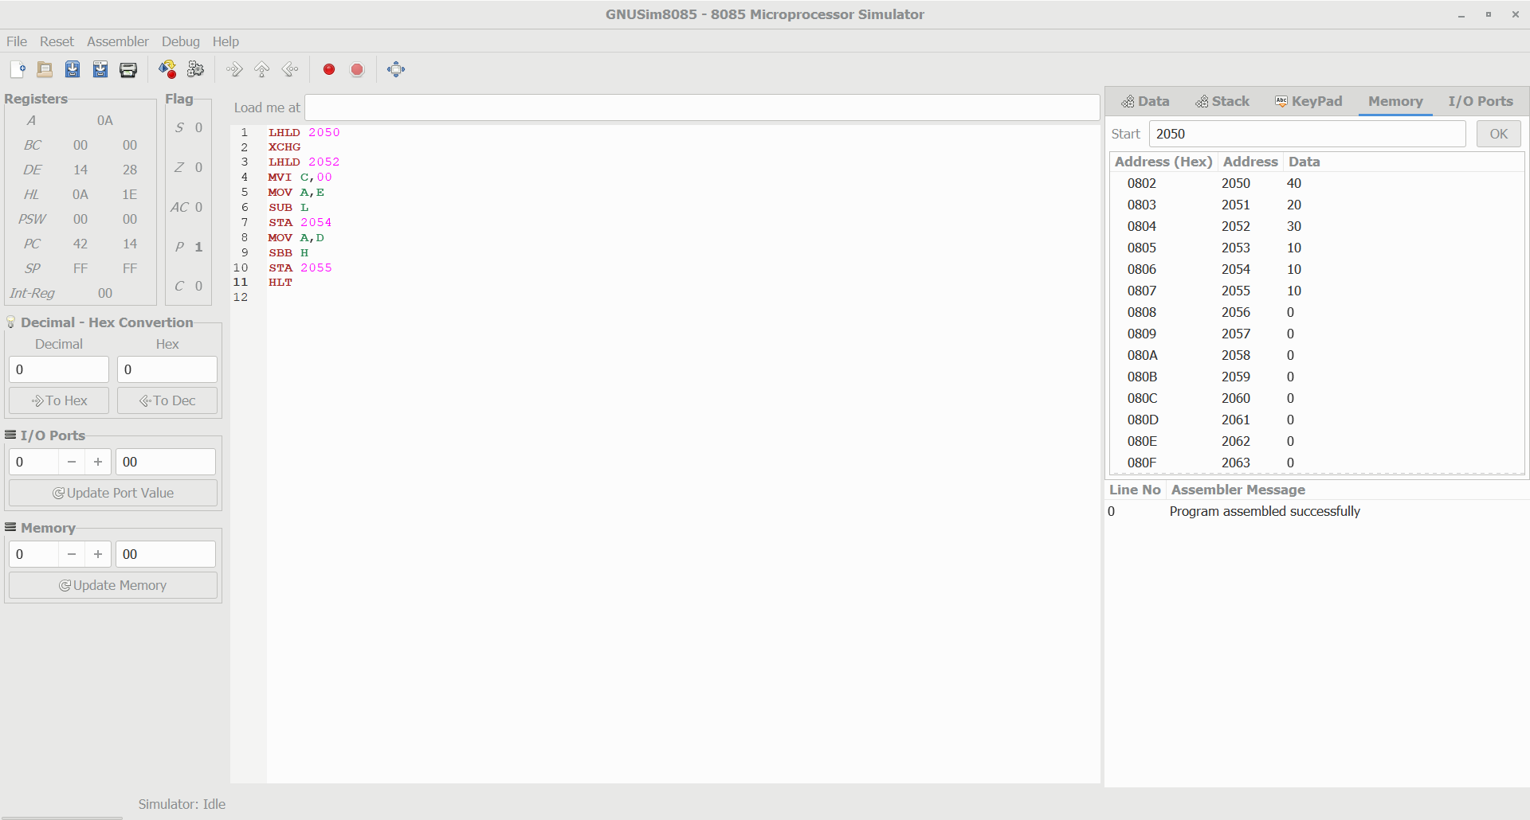

Write an assembly language program for multiplying two 16-bit datausing 8086 processor.

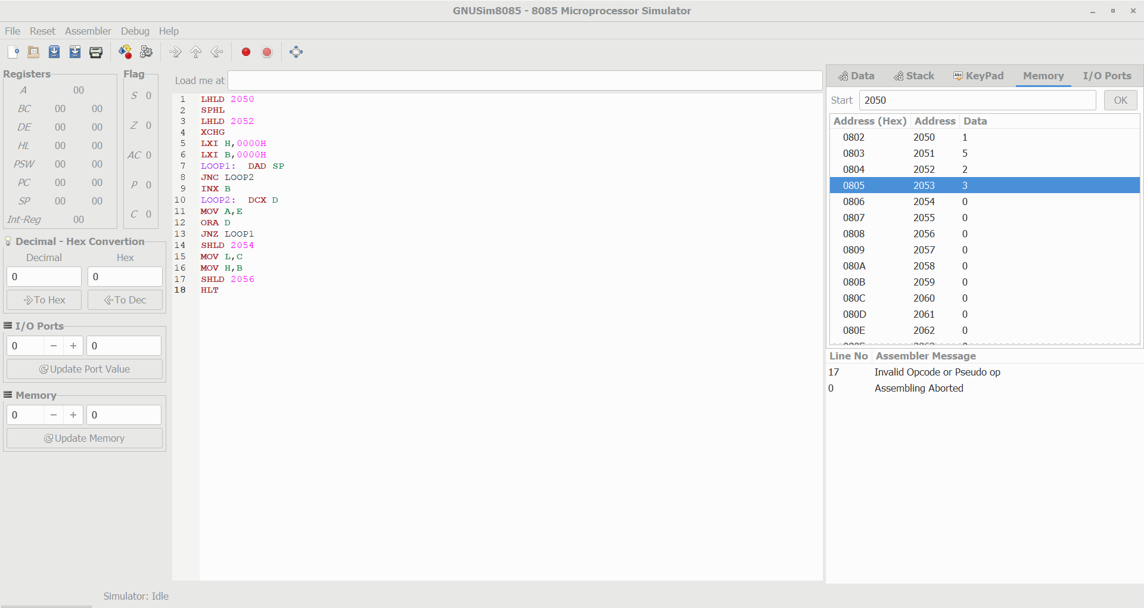

Design and implement 3-bit full adder using logisim simulator

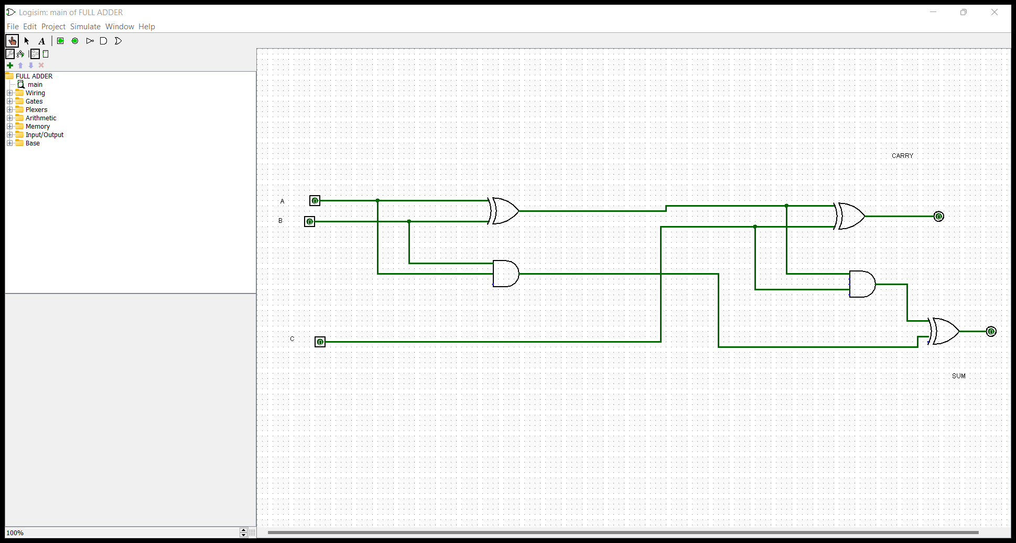

Design and implement 2-bit half adder with NOR gates using logisim simulator.

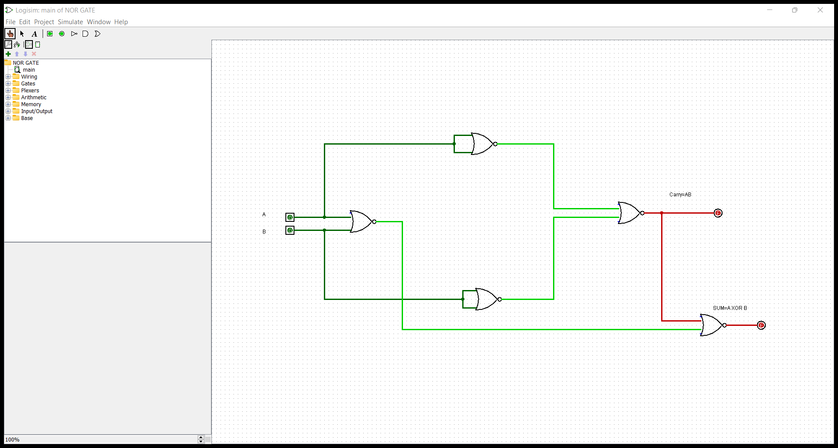

Design and implement 2-bit half adder using logisim simulator.

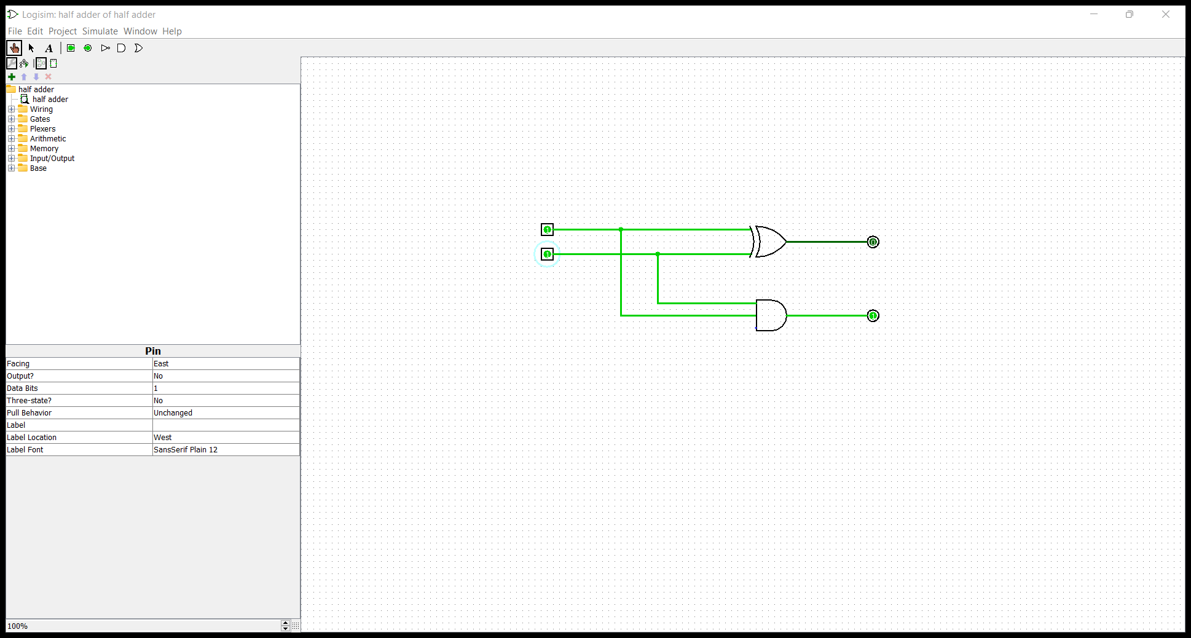

Design and implement 2-bit half adder with NAND gates using logisim simulator.

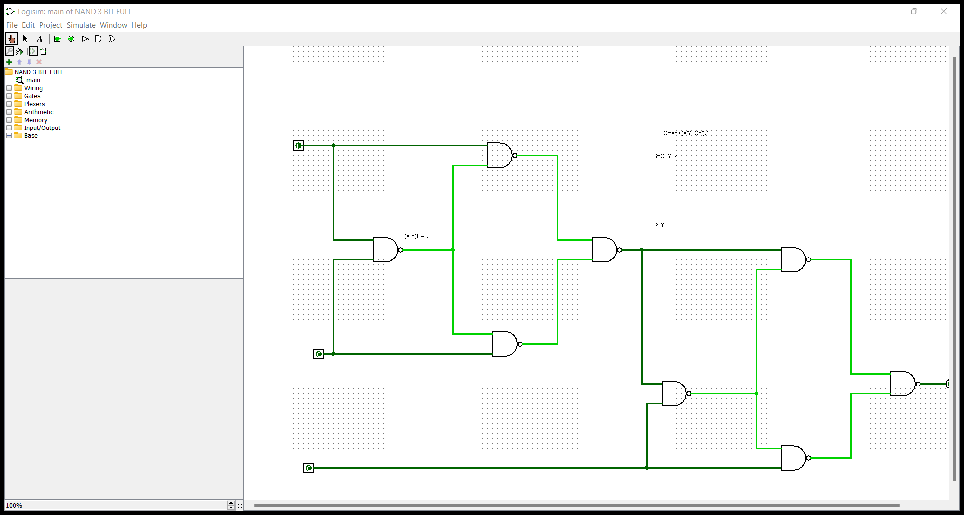

Design and implement 3-bit Full adder with NAND gates using logisim simulator.

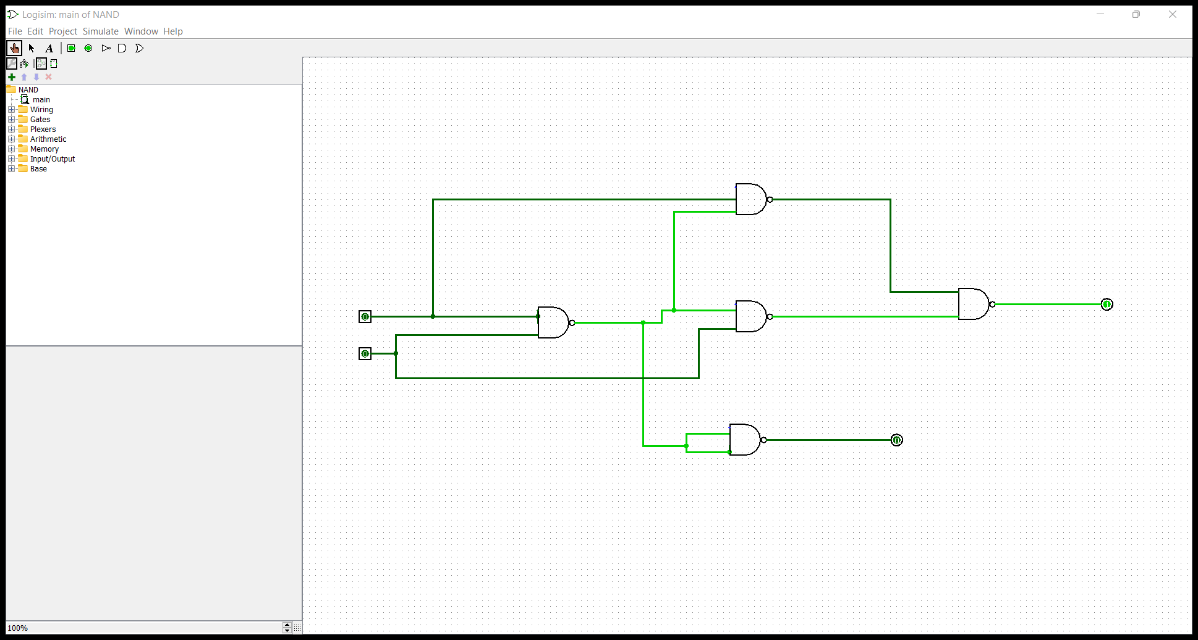

Design and implement 3-bit Full adder with NOR gates using logisim simulator.



Design and implement 4-bit ripple carry adder circuit using logisim simulator.

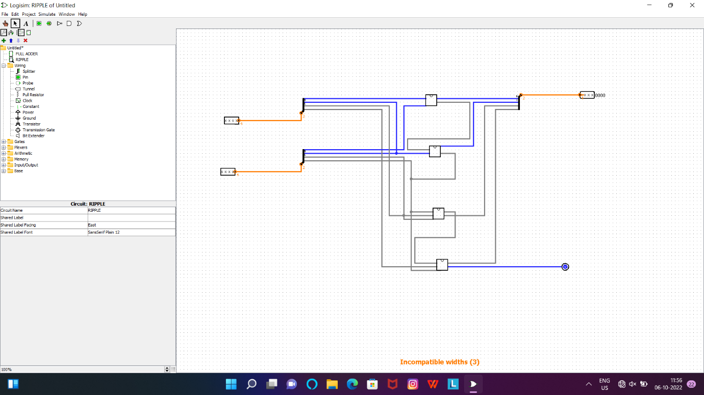

Write an assembly language program for adding two 8-bit data A7 A6 A5 A4 A3 A2 A1 A0 and B7 B6 B5 B4 B3 B2 B1 B0 using 8085 processor.

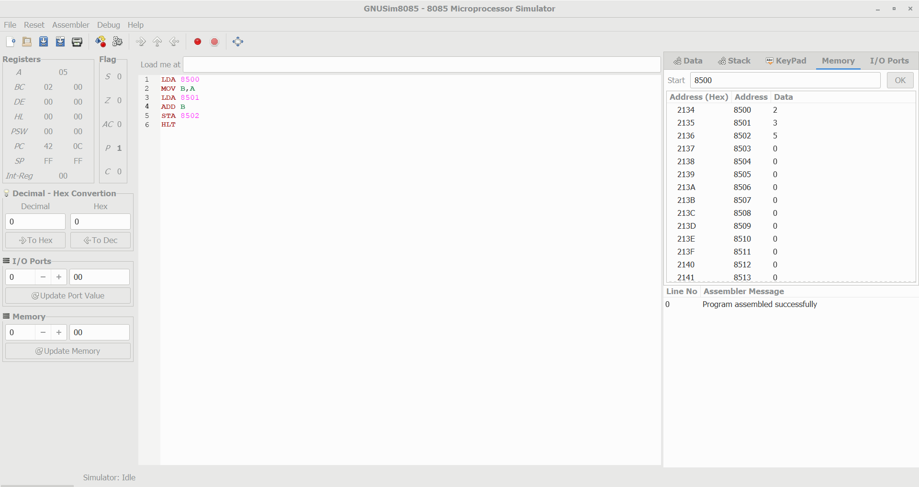

Write an assembly language program for multiplication of two 8-bit data A7 A6 A5 A4 A3 A2 A1 A0 and B7 B6 B5 B4 B3 B2 B1 B0 using 8085 processor.

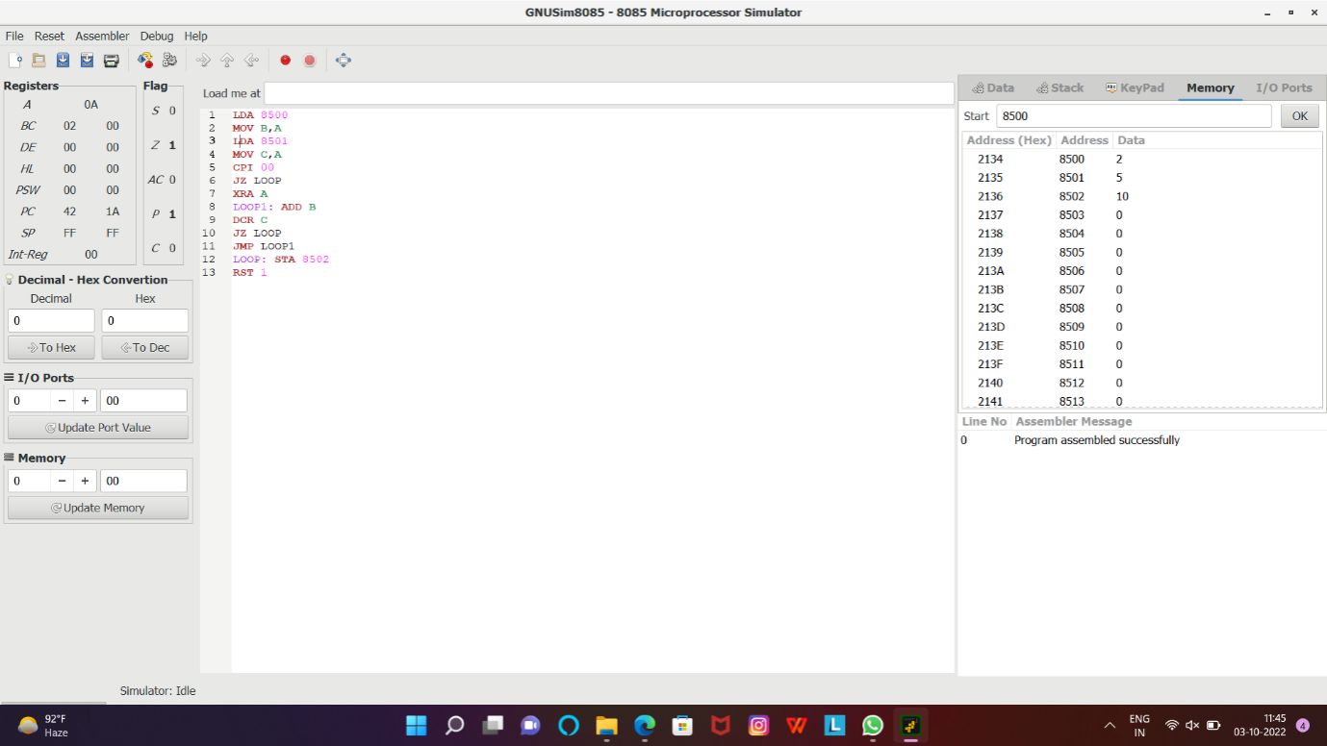

Write an assembly language program for subtraction of two 8-bit data A7 A6 A5 A4 A3 A2 A1 A0 and B7 B6 B5 B4 B3 B2 B1 B0 using 8085 processor.

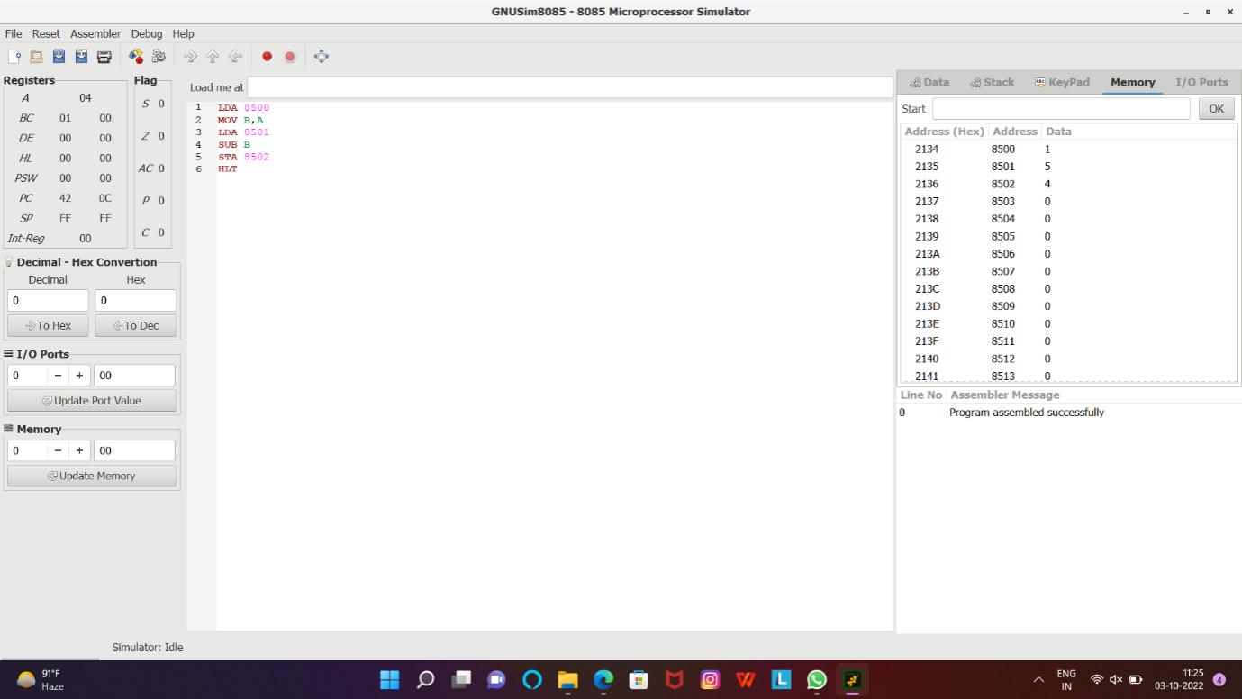

Write an assembly language program to swap two 8-bit datausing 8085 processor.

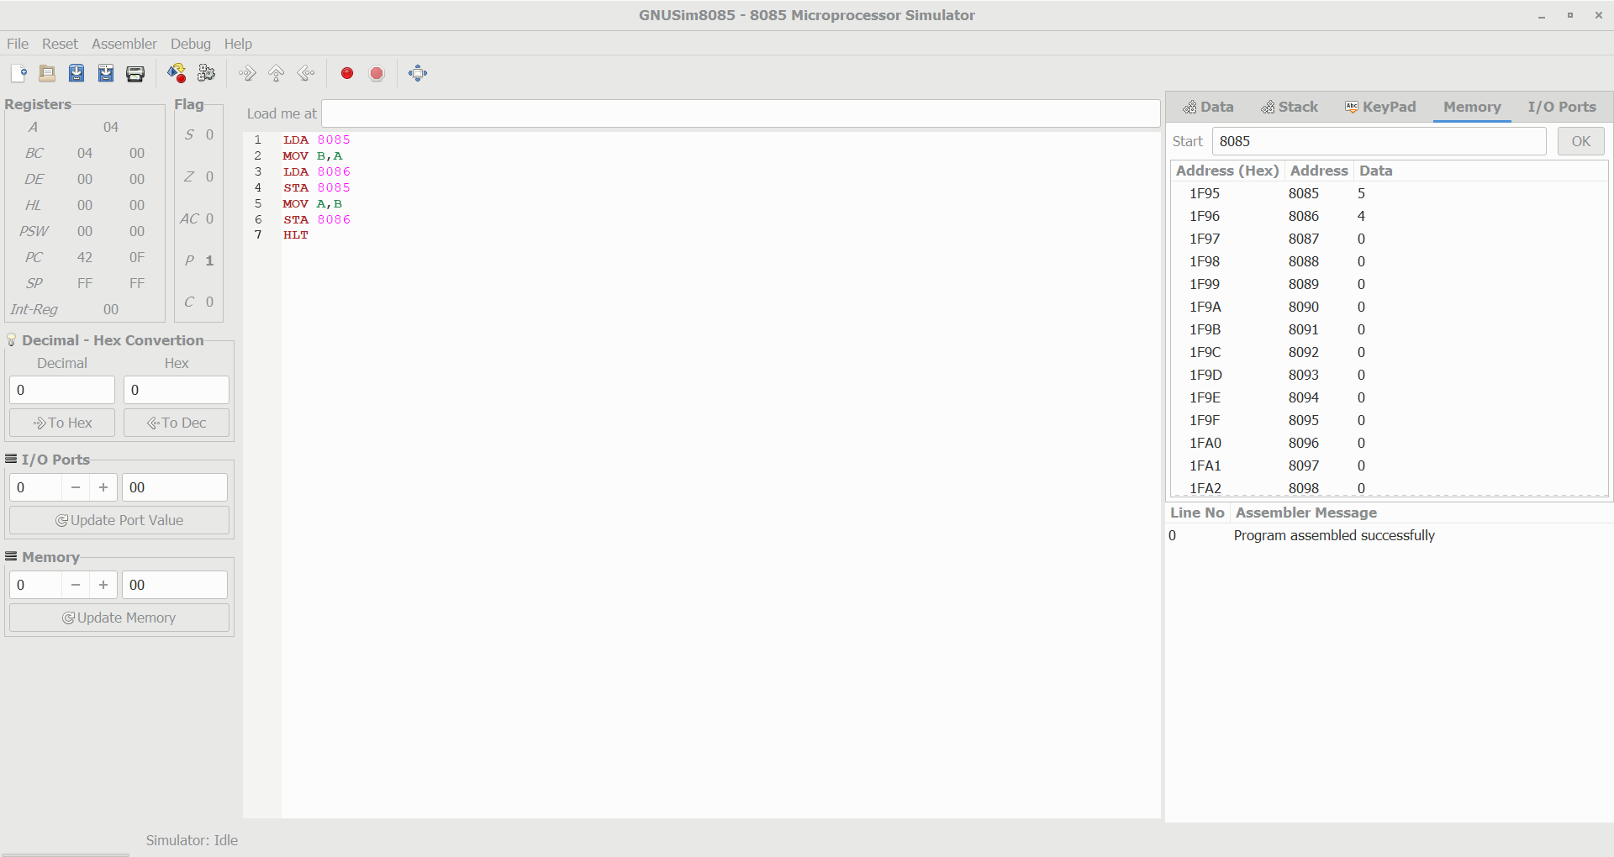

Write an assembly language program to find factorial of n in the given number.

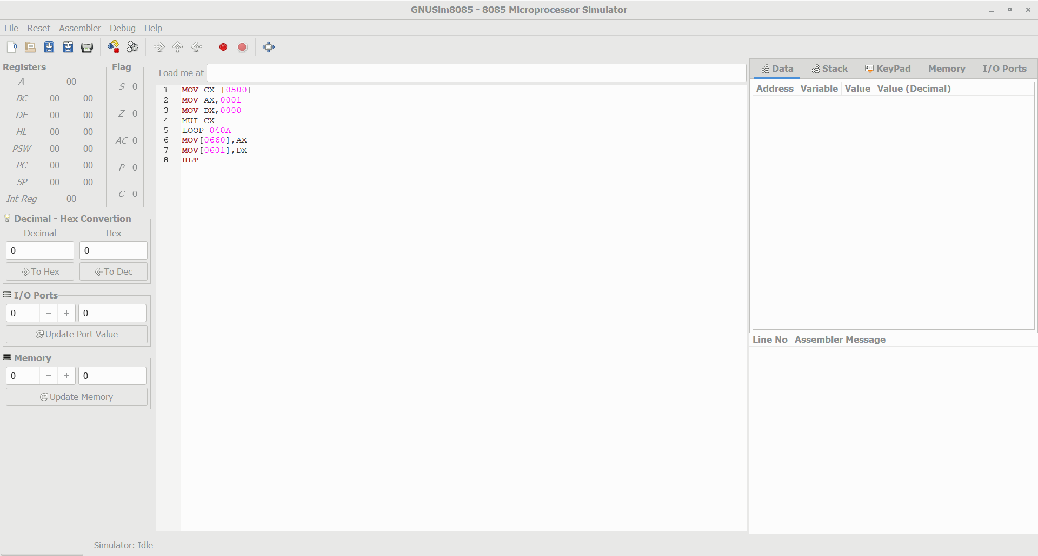

Write an assembly language program to find the given 8-bit number is Prime or not using 8085 processor.

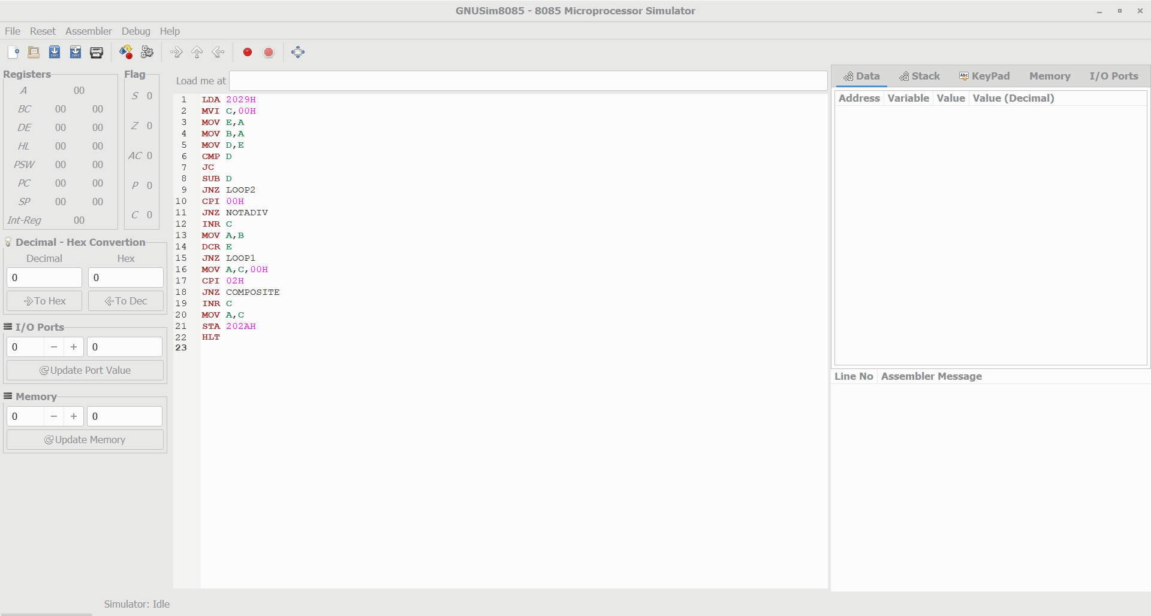

Write an assembly language program for division of two 8-bit data A7 A6 A5 A4 A3 A2 A1 A0 and B7 B6 B5 B4 B3 B2 B1 B0 using 8085 processor.

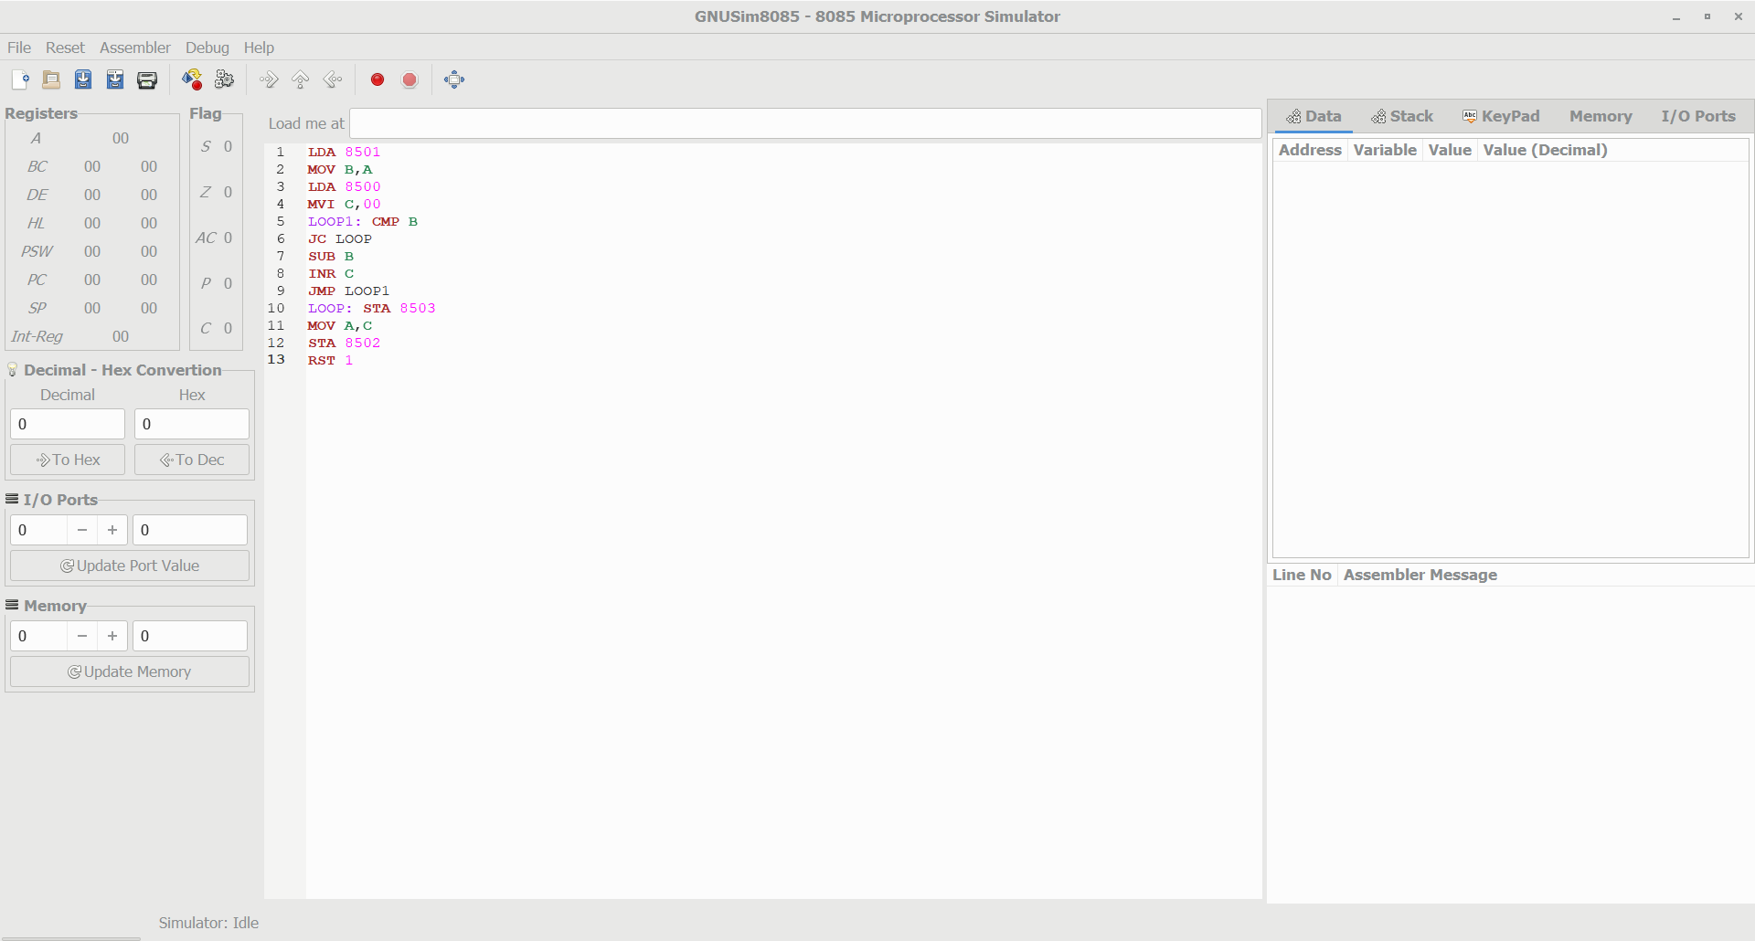

Design of 2 stage pipeline for addition of two numbers using any high level language.

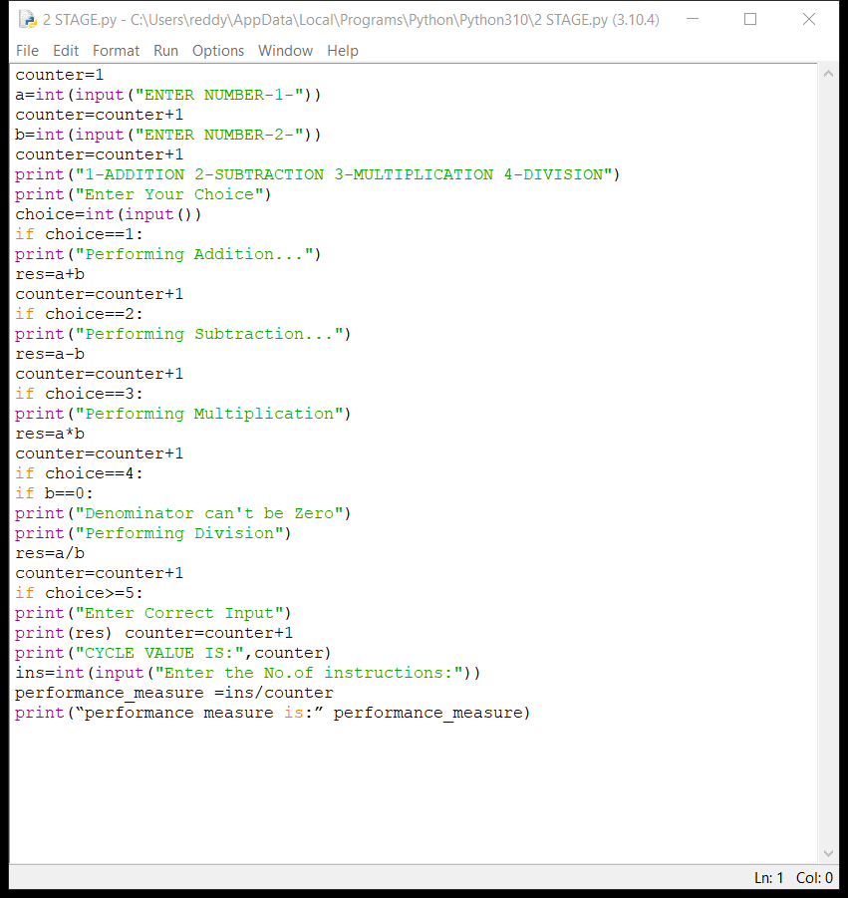

Design of 3 stage pipeline for AND of two numbers using any high level language.

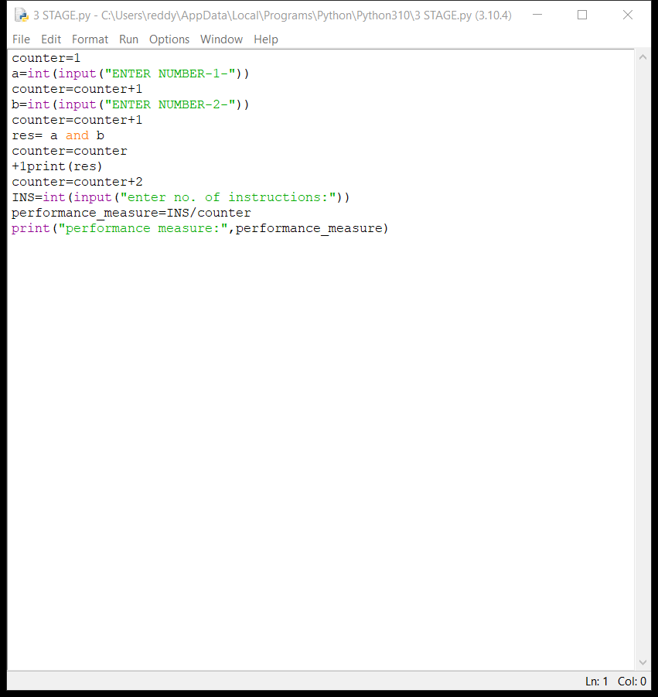

Design of 2 stage pipeline for subtraction of two numbers using any high level language

